**DWHM LAB # 2**

**FIRST**

1. A book is identified by its ISBN number, and it has a title, a price, and a date of publication. It is published by a publisher, which has its own ID number and a name. Each book has exactly one publisher, but one publisher typically publishes multiple books over time.

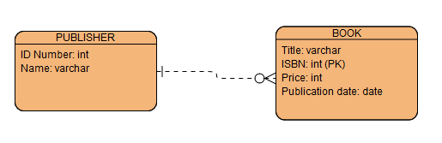

***PUBLISHER***

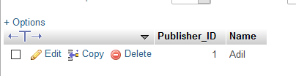

**BOOK**

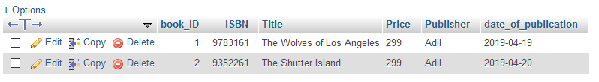

**SECOND**

1. A piano manufacturer wants to keep track of all the pianos it makes individually. Each piano has an identifying serial number and a manufacturing completion date. Each instrument represents exactly one piano model, all of which have an identification number and a name. In addition, the company wants to maintain information about the designer of the model. Over time, the company often manufactures thousands of pianos of a certain model, and the model design is specified before any single piano exists.

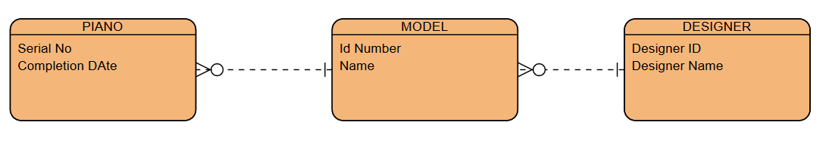

***PIANO***



***MODEL***



***DESIGNER***



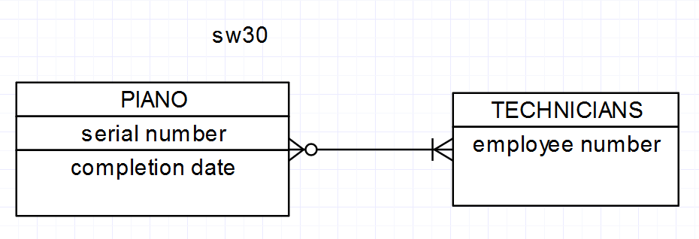

***TECHNICIANS***



**THIRD**

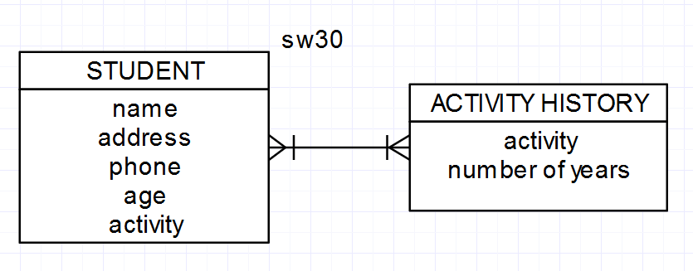

***STUDENT***



***ACTIVITY HISTORY***



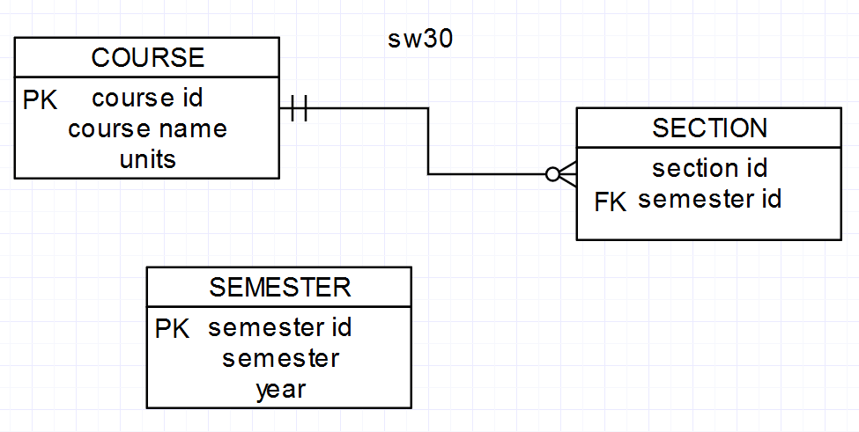

***COURSE***



***SECTION***



***SEMESTER***

